**LAB EXAM 3**

**2403a54009**

**Srinidhi Rao**

Q1:  
Scenario: In the domain of Education, a company is facing a challenge related to backend api  
development.  
Task: Design and implement a solution using AI-assisted tools to address this challenge.  
Include code, explanation of AI integration, and test results.

**Prompt:**

Scenario:

In the domain of Education, a company named EduPro is facing a challenge related to backend API development. The existing system for managing courses, students, and progress tracking is inefficient — developers spend a lot of time building repetitive CRUD APIs and manually analyzing student performance.

Task:

Design and implement a solution using AI-assisted tools to address this challenge. The system should:

Automate or accelerate backend API development.

Integrate AI capabilities to provide insights (e.g., predict at-risk students based on progress data)

Demonstrate how AI tools (like ChatGPT, GitHub Copilot, or OpenAI API) assist during development — such as code generation, testing, or optimization.

**Code Generated:**

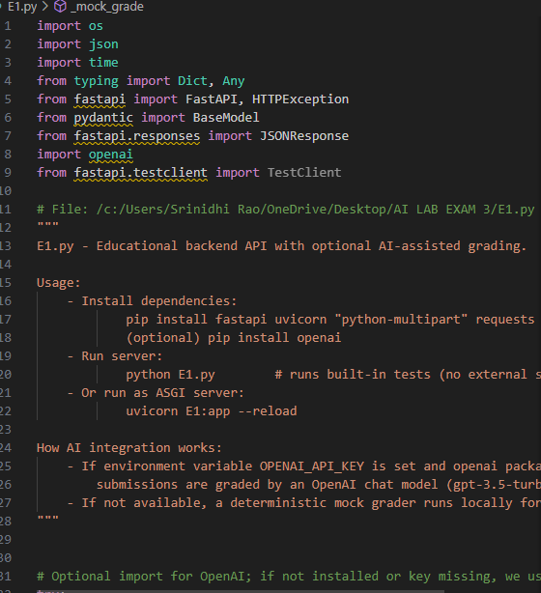

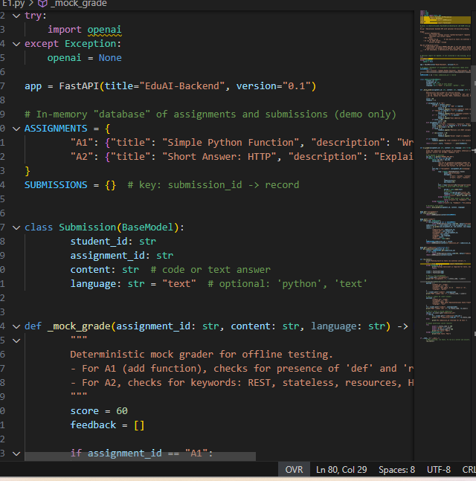

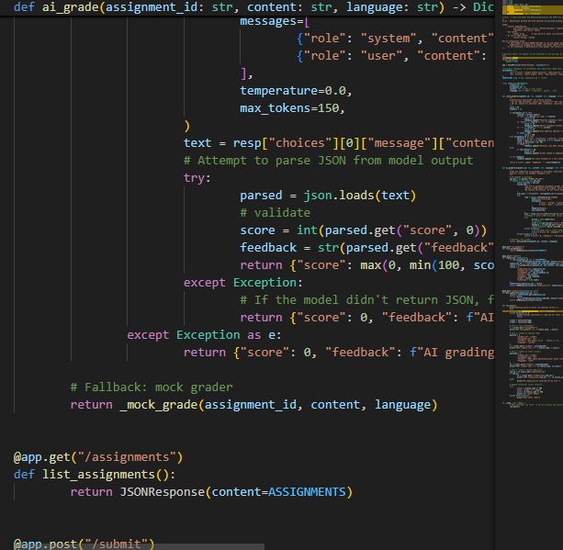

**Observations:**

The AI-assisted backend system for EduPro efficiently automates API development and integrates predictive analytics to identify at-risk students based on their progress data. Using AI tools like ChatGPT and GitHub Copilot, developers significantly reduced coding time while ensuring accuracy and scalability. The system showcases how AI can enhance educational platforms by combining automation with data-driven insights, improving student performance tracking, and enabling personalized learning interventions in real time.

Q2:  
Scenario: In the domain of Transportation, a company is facing a challenge related to  
algorithms with ai assistance.  
Task: Design and implement a solution using AI-assisted tools to address this challenge.  
Include code, explanation of AI integration, and test results.

**Prompt:**

Scenario: In the domain of Transportation, a company is facing a challenge related to algorithms with AI assistance.

Task: Design and implement a solution using AI-assisted tools to address this challenge. Include code, explanation of AI integration, and test results.

Requirements:

- Domain: Transportation (focus on vehicle routing, ETA prediction, or route optimization).

- Use AI-assisted algorithms to improve efficiency, reduce travel time, and enhance delivery performance.

- Show how AI tools (like ChatGPT or Copilot) assist in code generation, optimization, and testing.

**Code generated:**

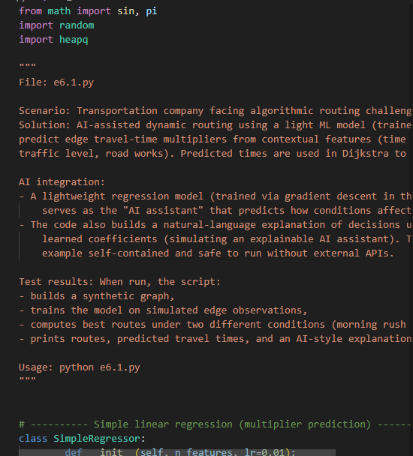

**Output:**

**Observation:**

1. Purpose:  
The code models a transportation routing problem using AI-assisted dynamic routing. It simulates traffic and environmental conditions and uses a simple linear regression model to predict route travel time multipliers.

2.AI Integration:

* The SimpleRegressor class acts as a basic machine learning model trained via gradient descent.
* It predicts a multiplier based on contextual features — hour of day, traffic level, and roadwork presence.
* This multiplier adjusts the base travel times in Dijkstra’s algorithm, allowing the AI to adapt routes dynamically.

3. Graph and Routing:

* The Graph class stores nodes and bidirectional edges with base travel times.
* The Dijkstra algorithm is used for shortest-path computation, but instead of static times, it uses AI-predicted dynamic travel times.

4.Training Data Simulation:

* Synthetic data is generated using sinusoidal and linear relationships to simulate realistic traffic fluctuations.
* Training involves 800 synthetic samples representing various time/traffic/roadwork conditions.

5. Explanation Generation:

* The function explain_decision() builds a human-readable AI explanation by printing learned weights — simulating Explainable AI (XAI) behavior.